**Week 1 Questions**

1. Identify a specific interface, which requires some improvement. You must conduct research into the interface, and then redesign the chosen interface with your knowledge. Outline when, how and why this interface is used.

*The interface chosen is an art college website. This website is used for prospectus students searching for information about the college.*

2. What methods are you going to use to gain more knowledge of this type of system – internet research, use of similar systems, interviews, journal articles …?

*We are going to use the internet and the dit website to gain more knowledge about this type of system.*

3. What *process* or *life-cycle* is the most suitable for the redevelopment of your system? Why is this one more suitable than others? How is usability factored into the process?

*We will be using the prototyping life-cycle for this system. We chose this one due to the feedback aspect. As stated evaluation and feedback are essential for this process. As this is a college website we felt that a process that has a working prototype would be best. As it relies on a working prototype, to test and change to the user’s needs, it can easily be tested for usability for the different users.*

4. Discuss the different types of requirements that are **currently** in this system. Through what methods have you identified these? Draw a use-case diagram for your system.

*As this system is already in place the site will need to be redesigned and improved. For the redesigning we will need a number of people including a team lead, html expert and graphic designer. As it is an art college we will need the graphic designer to help design the layout as it should be visually pleasing. The hardware and software is already there so we won’t need to develop new ones. We will have to completely overhaul the HTML and layout. The login system is working perfectly fine so that will not need to be touched.*

*In short we need to redesign the layout of the front end website to make it more visually appealing, garner more interest and to make it more user friendly.*

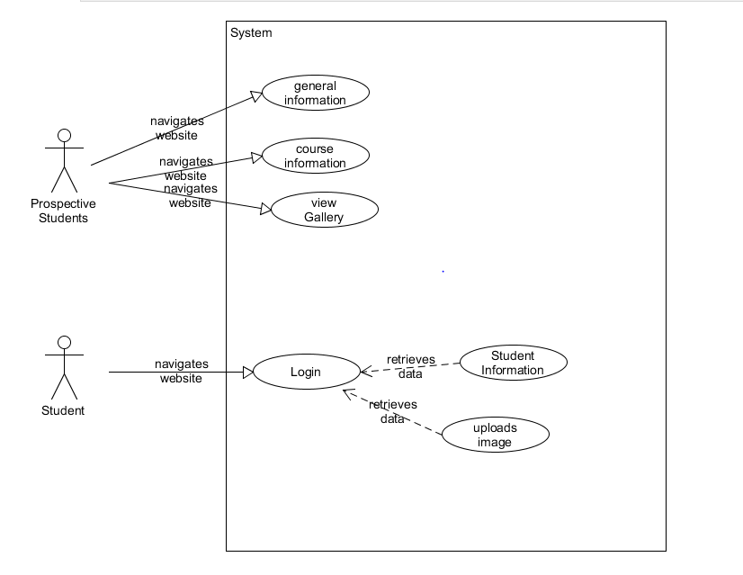

5. What user group(s) is your choice of interface focused on?

*The user groups that the interface is focused on is students, teachers and prospectus students.*

*6.* What changes have you decided to make? Use at least one interaction model (7 Stages of Action/Keystroke Level Model/…) and one set of principles/guidelines to analyse the **current** interface.

*We have decided to change the layout of the webpage. For this project we will be using mostly the position and point interaction model. This is due to the user’s mostly using the mouse to access the pages. In comparison the Keystroke level model would only be used by students. The guideline to analyse the current interface are ease of use and speed of interactions with the website.*

7. Create a **brief** initial low fidelity prototype to be used for product conceptualisation. (You can do this with pen and paper, then photograph it with a phone, paste it into a document for your (first) submission – the brief answers to these questions. Keep a copy for the Report.)

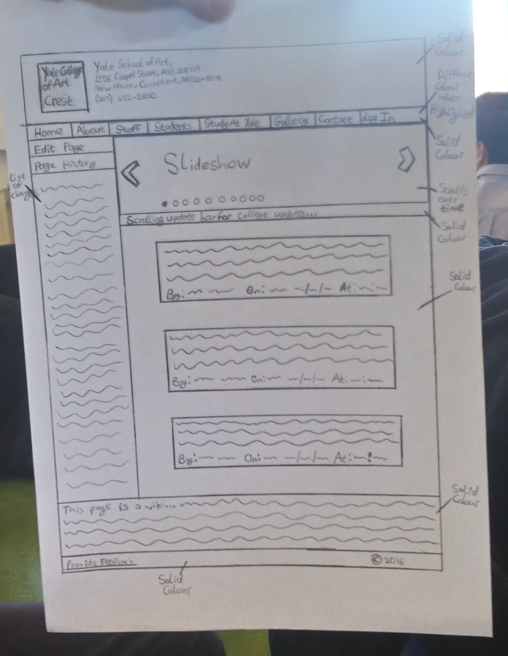

*Sample Answer*

***Week 1***

***Interface chosen***

*This is the front page of the interface that we have chosen for our project. We felt we could improve on this interface.*

***Methods of Research:***

*Our methods of research for this interface were the internet and we also gained an interview with an employee of the newspaper that owns the webpage, he gave us a insight on how the website is run and background information on why the website isn’t as good as rival newspapers.*

***Life Cycle:***

*The Star Life Cycle is the one chosen for this website. The Star Life Cycle Design Approach is centered on evaluation and doesn’t specify order to the activities surrounding this evaluation. It has a high level of iteration throughout the design process. The star life cycle approach has the great benefit of being able to utilise user evaluation throughout the whole design process, adapting to the needs of the users as they are discovered and as they (invariably) change. This is ideal for websites as they must be user friendly and constant feedback is paramount to a websites success.*

***Use Case Diagram:***

*Above is a simple use case of our low fidelity prototype. This will be used in the construction of our medium fidelity prototype and then in the more comprehensive medium fidelity prototype.*

***USER GROUPS:***

*The user groups that this website is focused on would be late 20s to early 50's users with some knowledge of how to use websites.*

***Interaction Models 7 stages of action:***

|  |  |
| --- | --- |
| *Forming the goal:* | *Browsing the website* |
| *Forming the intention:* | *To enter the correct key sequence to get to desired page* |
| *Specifying the action:* | *To move the body to reach the appropriate buttons to browse the web* |
| *Executing the action:* | *Pressing the keys and getting to site* |
| *Perceiving the state of the world:* | *Browsing the website and seeing if it works* |
| *Interpreting the state of the world:* | *The link brings you to another page* |
| *Evaluating the outcome:* | *Website did not perform as expected* |

*This interface has a gulf of evaluation as the webpage linked to an outside webpage.*

***Low Fidelity Prototype:***

*Below is an image of a low fidelity prototype which was drawn on a sheet of paper this will be the basis for further prototypes. With our low fidelity prototype our aim was to get the layout and build on this layout. We would also implement some of the cognitive processes like grouping, good visibility of the main pages and easily accessible interface.*